**Experiment-5**

**(CPU Scheduling)**

**1) First Come First Serve (FCFS):**

**Code:**

pno,at,bt,ct,tat,wt=[],[],[],[],[],[]

n=int(input("Enter the number of processes: "))

for i in range(n):

pno.append(i+1)

for i in range(n):

x=int(input("Enter the arrival time for" +str(pno[i])+":"))

at.append(x)

print(at)

for i in range(n):

x=int(input("Enter the burst time for" +str(pno[i])+":"))

bt.append(x)

for i in range(n):

ct.append(0)

tat.append(0)

wt.append(0)

print(bt)

c_bt=0

t_at=at[:]

print(t_at)

print(at)

max_at=max(at)

f=0

while(f<=(max(pno)-1)):

t1=min(t_at)

print(t1)

if(t1<=c_bt):

t2=at.index(t1)

c_bt+=bt[t2]

ct[t2]=c_bt

t_at.remove(t1)

tat[t2]=ct[t2]-at[t2]

wt[t2]=tat[t2]-bt[t2]

if(at[t2]==0):

at[t2]=1+max_at

else:

at[t2]+=max_at

f+=1

else:

c_bt+=1

print(ct)

print(tat)

print(wt)

print("average of TAT is "+str(sum(tat)/float(n)))

print("average of WT is "+str(sum(wt)/float(n)))

**Output:**

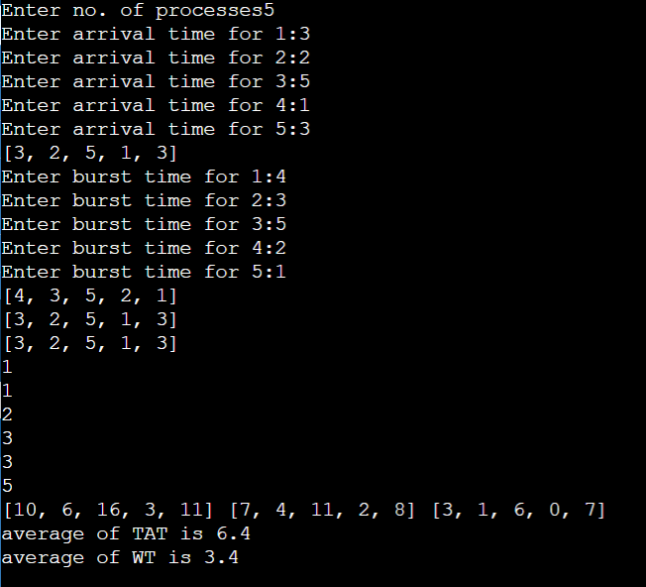

**2)Shortest Job First (SJF):**

**Code:**

pno,at,bt,ct,tat,wt = [],[],[],[],[],[]

n=int(input("Enter no.process :"))

for i in range(n):

pno.append(i+1)

for i in range(n):

x=int(input("Enter arrival time for process"+str(pno[i])+" :"))

at.append(x)

print(at)

for i in range (n):

x=int(input("Enter burst time for process"+str(pno[i])+" :"))

bt.append(x)

ct.append(0)

tat.append(0)

wt.append(0)

c=[]

z=[]

z=bt[:]

c=at[:]

c.sort()

s=c[0]

print(s)

dum=[]

flag=0

tt=0

w=0

while(flag<max(pno)):

for i in range(n):

if(at[i]<=s and bt[i]!=0):

dum.append(bt[i])

minbt = min(dum)

d = bt.index(minbt)

s=s+minbt

tt=s-at[d]

w=tt-bt[d]

bt[d]=0

del ct[d]

del tat[d]

del wt[d]

ct.insert(d,s)

tat.insert(d,tt)

wt.insert(d,w)

flag+=1

dum=[]

print(ct)

print(tat)

print(wt)

**Output:**

